**Project Design Phase**

**Problem – Solution Fit Template**

|  |  |
| --- | --- |
| Date | 25.june 2025 |
| Team ID | LTVIP2025TMID53135 |
| Project Name | LearnHUb:Your Center For Skill Enhancement |
| Maximum Marks | 2 Marks |

**Problem – Solution Fit Template:**

The Problem-Solution Fit simply means that you have found a problem with your customer and that the solution you have realized for it actually solves the customer’s problem. It helps entrepreneurs, marketers and corporate innovators identify behavioral patterns and recognize what would work and why

**Purpose:**

❑ Solve complex problems in a way that fits the state of your customers.

❑ Succeed faster and increase your solution adoption by tapping into existing mediums and channels of behavior.

❑ Sharpen your communication and marketing strategy with the right triggers and messaging.

❑ Increase touch-points with your company by finding the right problem-behavior fit and building trust by solving frequent annoyances, or urgent or costly problems.

❑ **Understand the existing situation in order to improve it for your target group.**

**Template:**

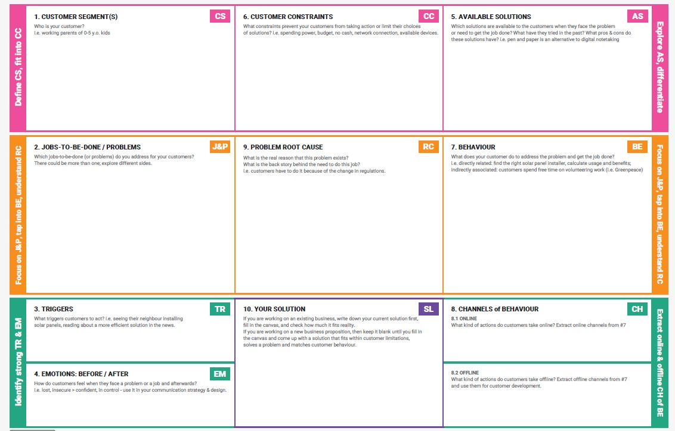

|  |  |
| --- | --- |
| **Section** | **LearnHub-Focused Answer** |
| 1. **Customer Segment** | College students, working professionals, skill-seekers, job aspirants. |
| 2. **Jobs-To-Be-Done** | Learn in-demand skills online, get certified, find job-oriented content, flexible learning. |
| 3. **Triggers** | Need to upskill for jobs, see peers enrolling in courses, social media ads, career awareness. |
| 4. **Emotions: Before/After** | Before: Confused, insecure, unmotivated. After: Confident, capable, career-focused. |
| 5. **Available Solutions** | YouTube, Coursera, Udemy (often expensive or unstructured); LearnHub aims to simplify. |
| 6. **Customer Constraints** | Lack of money, poor internet, time issues, no mentorship. |
| 7. **Behaviour** | Search online, ask peers, watch free content, delay actual learning due to doubts. |
| 8. **Channels** 8.1 Online | Social media, mobile apps, browser search. 8.2 Offline: Word of mouth, college workshops |
| 9. **Root Cause** | Traditional learning lacks flexibility; online learning platforms are often costly or complex. |
| 10. **Your Solution** | LearnHub – simple, accessible, modular skill-building platform with community and mentorship support. |

References:

1. <https://www.ideahackers.network/problem-solution-fit-canvas/>
2. <https://medium.com/@epicantus/problem-solution-fit-canvas-aa3dd59cb4fe>